

Hum101 Assignment-02

Name: Tahsin Raihan Robbani
Id: 22201344
Section: 11

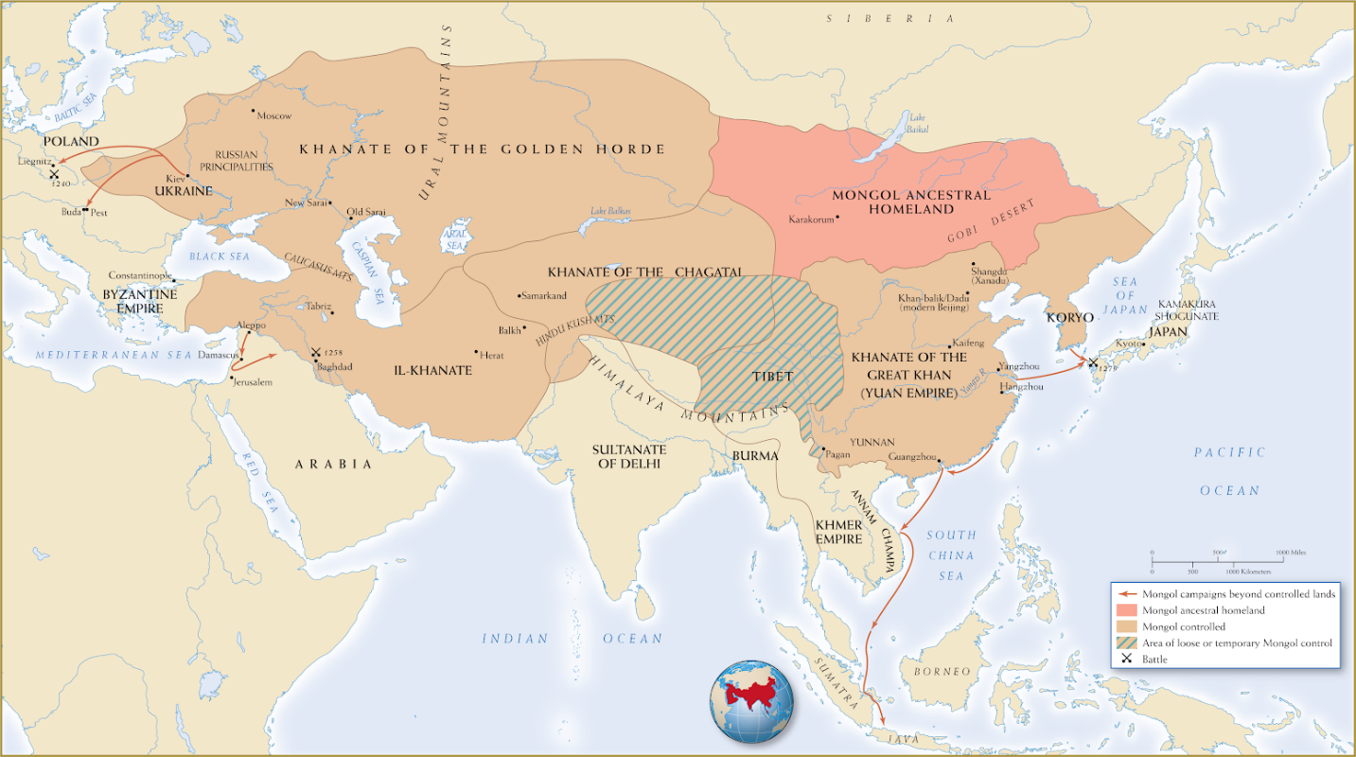

Image 1: Mongol Empire Expansion Map

This image symbolizes one of the most remarkable territorial expansions in history and that is the Mongol Empire. It represents a gist of the Mongol Empire’s expansion by showing its division into four major khanates. They are the Khanate of the Golden Horde, the Il-Khanate, the Khanate of the Chagatai, and the Khanate of the Great Khan. Under the leadership of Genghis Khan and his successor, the Mongols united much of Eurasia from the Pacific Ocean to Eastern Europe (May, 2016). This map not only shows the expanse of Mongol empire but also reveals how these military campaigns created the Pax Mongolica. According to May (2016), Pax Mongolica is a period marked by relative peace that allowed for trade, cultural exchange, and diplomacy. This map also illustrates the interconnectedness of the ruled regions, facilitating the exchange of goods, technologies, and ideas. The Mongol government always promoted trade by safeguarding trade routes which made it safer for traders to move between areas. Here the Mongolia's homeland and its expanding regions highlight how the empire encouraged cross-cultural interactions. According to May (2016), the Mongols were not just rulers but also creators of an unimaginable global network. In summary, this map shows the dual face of the Mongol Empire, one is how they brutally expanded their territory, and the second is that they were also the facilitator who created the first truly global empire linking the world into a single economic sphere.

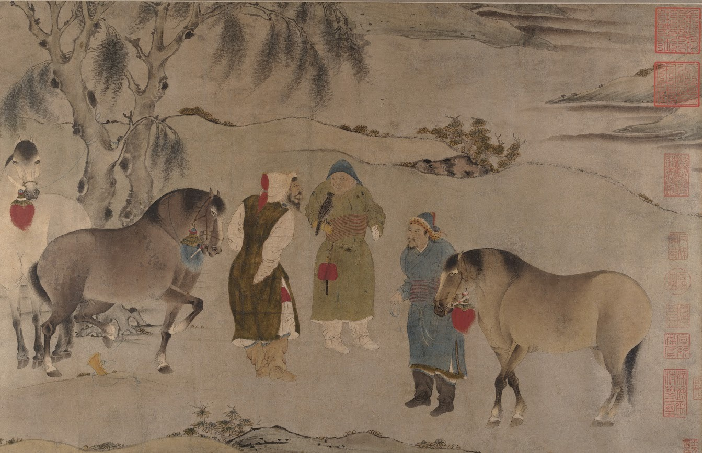

Image 2: Mongol Leaders and Horses

I believe this image shows Mongolian’s interacting with their horses. In that time, horses played an essential role in Mongol society. Especially in military and cultural contexts. According to Sinor (1972), the Mongol Empire's superior cavalry relied on remarkable horsemanship and mobility across vast terrains. It was a major factor in the conquest's success. Horses were not just tools of war, they were central to the Mongol way of life. They represented power, prestige, and cultural identity. Mongol’s mastery of horsemanship allowed them to move quickly and effectively. It helped their armies to cover long distances and to conquer large territories. This image also shows the importance of nomadic culture in Mongol society. Beyond warfare, horses provided food, materials for clothing, and transportation. This allowed the Mongols to stay self-sufficient when they were on the move. But relying on horses was not without disadvantages. Horses indeed gave them mobility, but they also required grazing land. So in places where grazing was limited, horses could get tired or sick, slowing the army down. Additionally, horses did not have the same advantage when fighting in urban areas or difficult terrain. Because of this, the Mongols had to adjust their battle tactics and employ foot warriors as necessary. This is also one of the reasons we did not see the Mongol’s conquer the sea and beyond. Even with these challenges, horses were at the heart of the Mongol Empire. It is their part of their existence and made them who they are.

Reference

May, T. (2016). Commercial queens: Mongolian khatuns and the Silk Road. Journal of the Royal Asiatic Society, 26(1/2), 89–106. https://www.jstor.org/stable/24756042
Sinor, D. (1972). Horse and pasture in Inner Asian history. Oriens Extremus, 19(1/2), 171–183. https://www.jstor.org/stable/44001260

